Great Leadership
Name
Institutional affiliation

Great leadership.
Introduction.
The Lighthouse personnel includes a team of sixteen individuals. The highest level of management includes a founder and CEO, Chairman, account director, and head of business operations and finance (TLH, n.d). The other personnel includes executive assistants and coaches, personal assistants, leadership coaches, a lawyer, a stylist, psychologists, and a medical doctor. The company has two offices, one in New York City at 131 West 33rd Street, and the other in London at Circus House, 26 Little Portland Street.


The Lighthouse is a company focusing on roles regarding board level and executive leadership across the globe. The company is mainly involved in finding individuals and representing them, as it is an executive search company. The company also creates partnerships that are victorious between individuals and their colleagues, who are the leaders (TLH, n.d). The company`s customer base is people seeking to hire leaders in their business, or when these people are looking for new challenges themselves.

The Challenge.
One of the employees working under the supervisor wanted a new career goal. They tried to change their career path from business development, which was their current role, to product managers. This was like a one hundred and eighty degrees U-turn. This was a challenge to the supervisor as this employee was very good at his current role, business development. The company and the supervisor included required the revenue and partnerships they were earning for the company while undertaking the task. Even if the supervisor and company wanted to retain them, they had no product management work available for them. And significantly, the employee was among the best people the company had on their payroll, and losing them would have been tragic. This employee had already decided they were going to pursuing their new career goal and that they would not change their minds regardless.


The Solution.
The supervisor made a decision, or a gamble, for lack of a better word, on whether to retain the employee, or prematurely let them go. The supervisor embraced the employee`s desire to pursue their passion. He made an agreement with him that included he continue carrying the job he was doing in business development. In turn, the supervisor would aid him to learn what product management entails. Notably, the supervisor was a product manager before his current role.
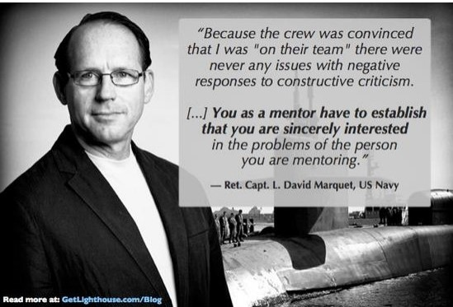
The Implementation.
The supervisor had worries about the employee`s change of interests, and that they would want to check out of their role in business development. The assistance he was giving on product management, also fueled the worries as he did not know if the encouragement on product development would affect the critical work the supervisor and the company needed from the employee. The supervisor did not do much to overcome these difficulties, as the employee was very committed in the role. Hence, it seemed that by helping the employee achieve what they desired, only then would they want to continue performing in their current role. Therefore, the supervisor or the company bought the employee best books that would help in furthering their knowledge about product management. Next, the supervisor created meetings for discussing product management with the employee. And finally, he introduced the employee to good product managers, to also increase their knowledge.
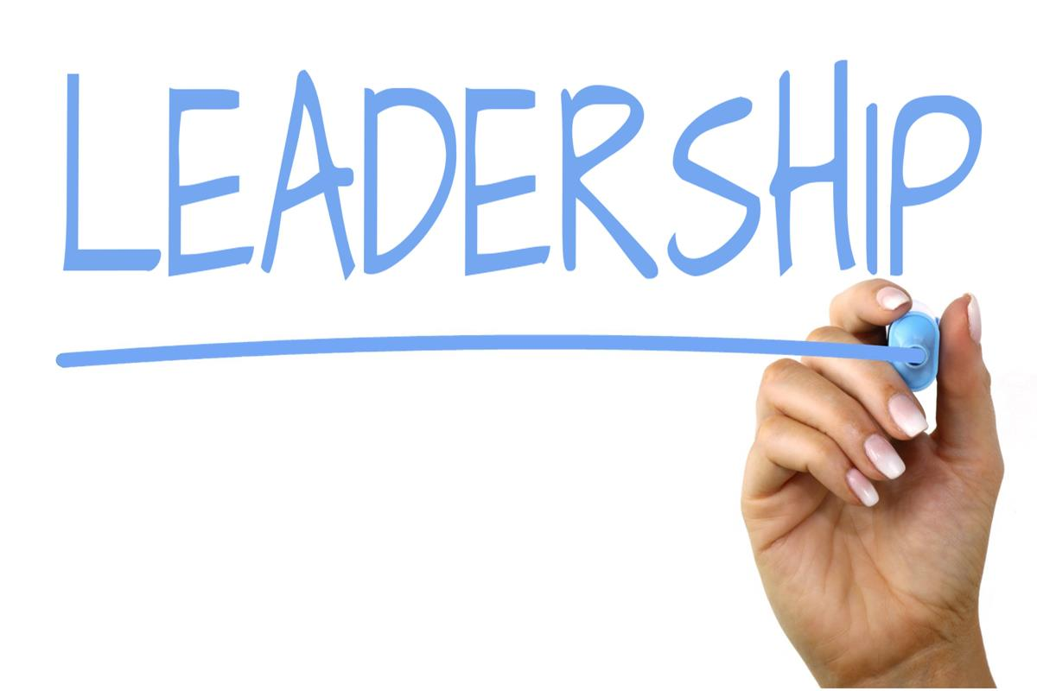

Results.
Significantly, the supervisor became better decision making. The first achievement involves the company, and the supervisor was able to achieve what they had anticipated from the employee in his current role. Meaning, that even though the employee wanted a new career goal, they still ended up meeting their expectations of the role they had at the time. Actually, during the period after his discussion on the change of career role, the employee did the best work ever. Another achievement was that the employee became better at product management. The reason for this was the books, discussions, and symposium-like meetings with good project managers.

Lesson learned.
To begin with, it is worth noting that even the smallest of efforts mean a lot to other people. The key reason for success were the recognition or awareness of the situation by the supervisor. This helped him to make the right decision when it came to aiding the employee. Because he also reciprocated the gesture by working in his current role, while also taking time in learning and building skills required for the change.
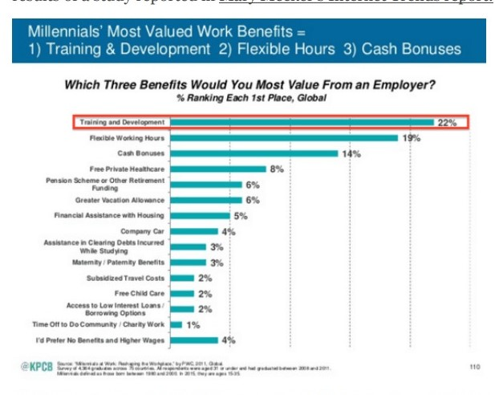
Notably, members of a team will always desire to continue growing career-wise to attain a promotion or align with their current job. Managers and supervisors should always support them, because the number of benefits that may come with it may be plentiful (Wageman, 2013). This is true because most people have a desire for growth and development while they work. By recognizing an employee`s desires, more work gets done. Supervisors should always identify what different employees may desire, as needs and wants are diverse between employees (Zelnik et al. 2012). Nonetheless, identification of work benefits such as training and development, flexible hours, and cash bonuses, can help reduce conflicts in the workplace.

References.
Zelnik, M., Maletič, M., Maletič, D., & Gomišček, B. (2012). Quality management systems as a link between management and employees. Total Quality Management & Business Excellence, 23(1), 45-62.
Wageman, R. (2013). Building great leadership teams for complex problems. Developing and enhancing teamwork in organizations: Evidence‐based best practices and guidelines, 121-153.
The Lighthouse Company (TLH). (n.d) https://www.thelighthousecompany.com/

